1ZZ-FE Throttle Body Swap
Disclaimer:
I am not responsible for any damage you may cause in the process of doing this mod as it may not be uncommon to cause check engine lights and some intakes may not fit the new throttle body.
Why swap throttle bodies?
The 1ZZ-FE engine is Toyota's 1.8L engine that comes in the Corolla and Matrix. The throttle body on this engine is 60mm, while the one on our puny 1NZ-FE is 54mm. So this mod is a great way to complement your intake and allow more air to flow into your engine.
What’s needed:
- Throttle body from a 1998-2002 corolla. These are 1ZZ-FE engines before the drive-by-wire conversion that is on the later Corolla and Matrix.
- Dremel with plenty of bits to remove material from the throttle body
- Something to plug coolant lines
- 10mm, 12mm wrenches and sockets
- Phillips head screw driver
- A sheet of aluminum big enough to make a sandwich plate
- Gasket paper
- Sharpie
- Tin snips
- Drill
- Needle nose pliers
- 2.5” hole saw
- 3/8” vacuum-tee
- 5/8” bypass cap

Here is a side-by-side comparison of the two. The throttle body on top is the new one, the bottom is our stocker.
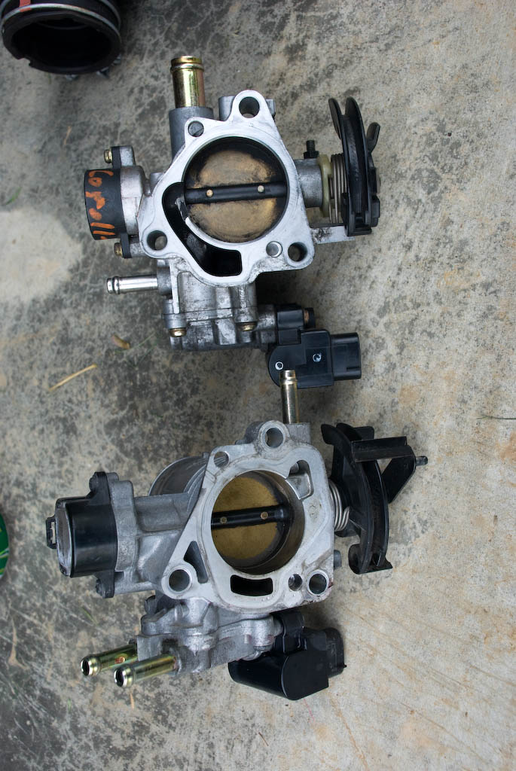
1. Remove intake
2. Unplug all sensor lines coming into the throttle body
3. Unhook the throttle cable (and cruise control cable, if you have it) from the throttle body
4. On the bottom of the throttle body, facing the firewall are two coolant lines. Take a pair of needle nose pliers, squeeze the clips, and pull the lines off of the throttle body. Be sure to plug these up or you will get coolant everywhere. Also note the side they came from as you will need this later on.
5. Take a 12mm ratchet and unbolt the throttle body, then remove it
6. Observe the surface you have to seal against on the intake manifold, the area that sealed against it on the stock throttle body, and the area that will have to seal against it on the new throttle body. You will see that there is going to be a huge vacuum leak if you just bolt it up.
7. To remedy this, you need to make a plate that will allow the new throttle body to seal completely, but allows the vacuum from the intake manifold to pass through it. I did this by laying a piece of gasket paper over the throttle body and gently tapping an impression of all edges into the paper. Once you have the impression of one throttle body, align it on the other and do the same thing. You can then cut out your gasket and use it to trace your sandwich plate onto the aluminum.
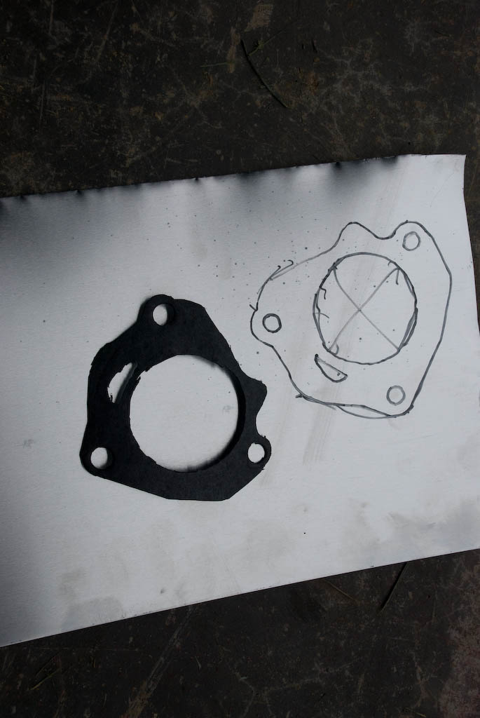
8. Take your sandwich plate pattern that you created from the gasket and cut it out with tin snips or whatever method you please. Then take your 2.5” hole saw, line it up, and drill out the hole for air to flow through, followed by your bolt holes, and the hole for the vacuum channel.
9. Test fit your plate and gasket on the intake manifold. It should slide on and off easily without binding. If it binds, find out with hole is out of alignment and enlarge it slightly. Repeat until it doesn't bind.
10. This is where the fun begins. You will notice that if you test fit your sandwich plate, gasket, and the new throttle body that the studs are not long enough to bolt to. So bust out your Dremel and remove the excess material until you can bolt it up. Try to keep the length of the remaining material similar to that of the stock throttle body on the top stud, or you will have to readjust your throttle cable since the bracket bolts to it.
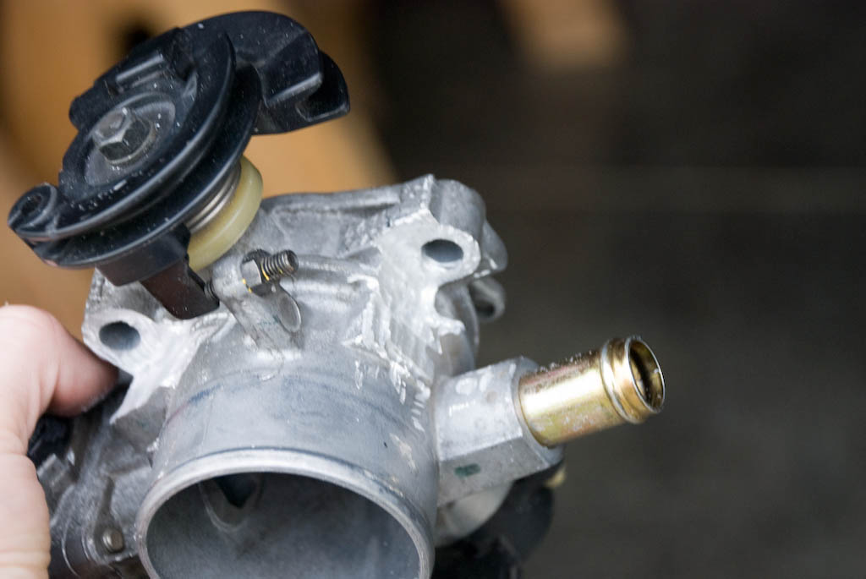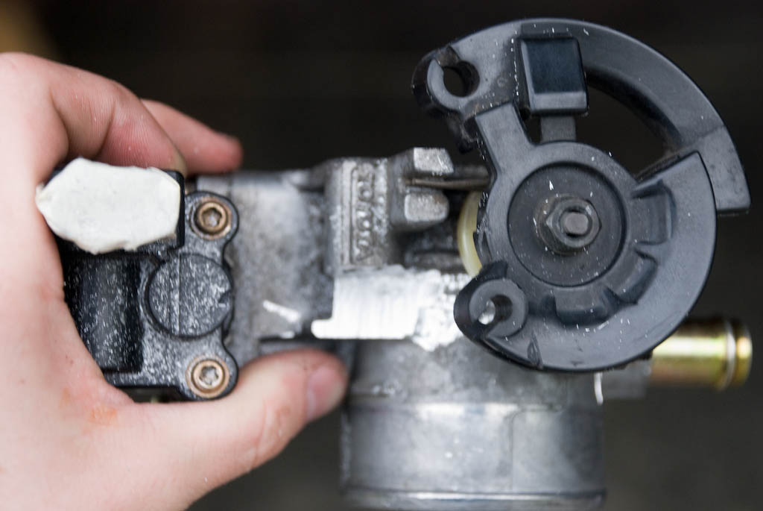
As you can see, there is a lot of material to remove. Take your time and don’t damage anything.
11. Once you have removed enough material to safely bolt the throttle body to the studs, you can bolt everything back up. It goes in this order: stock intake manifold -> your sandwich plate -> your gasket -> new throttle body.
12. Connect your throttle cable and sensor cables back up.
13. One of the big differences between the throttle bodies is that the 1ZZ TB lacks a vacuum bung for the EVAP line. The bung on the throttle body is used for the corolla breather line. The picture below demonstrates what I am referring to.
To remedy this problem, you will need to splice into the brake booster vacuum line that comes off of the manifold. This is the line with the hose clamp around it in the following picture (I have already tapped into the line here though).
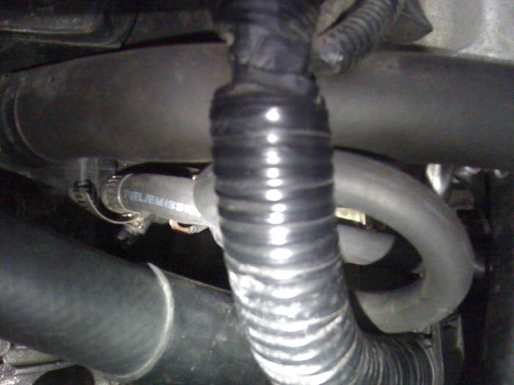
To do this, head up to your local AutoZone and pick up a 3/8” vacuum t and a 5/8” bypass cap. These usually come in packs with several other pieces. I used the following: Vacu-Tite! Part #47329
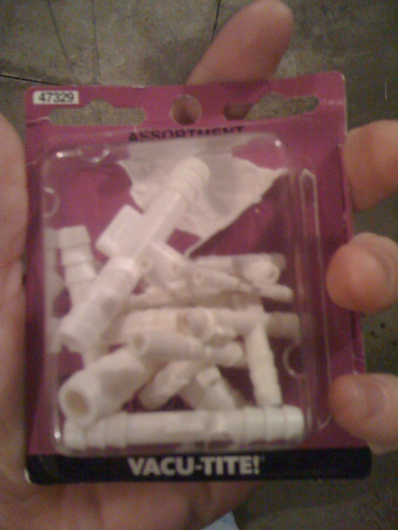

Help! Bypass Cap Assortment Part #02253
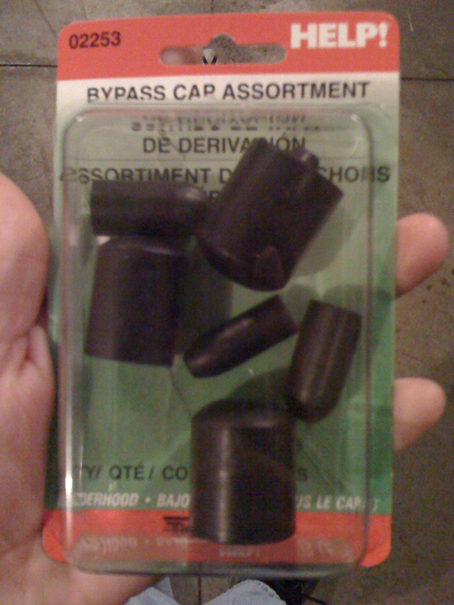
Once you have these, take your 3/8” vacuum-T and splice into the booster line near the end of the line on the manifold. Leave enough space so that this line will not kink when you hook everything back up. Plug the vacuum t into the line, then hook up the vacuum line from the EVAP solenoid to the remaining place on the fitting. The line from the EVAP solenoid is a bit smaller, but should stretch onto the fitting just fine. I would also recommend using hose clamps on this to prevent vacuum leaks...especially since this is the line to your brake booster.
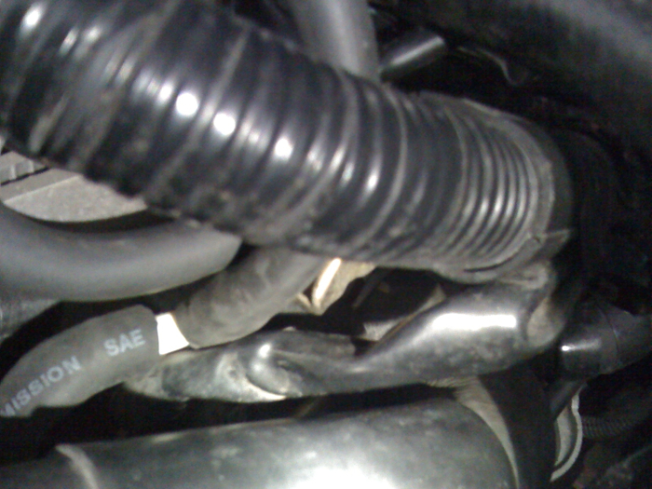
Finally, cap off the EVAP bung on the new throttle body by pushing the 5/8” bypass cap onto the bung.
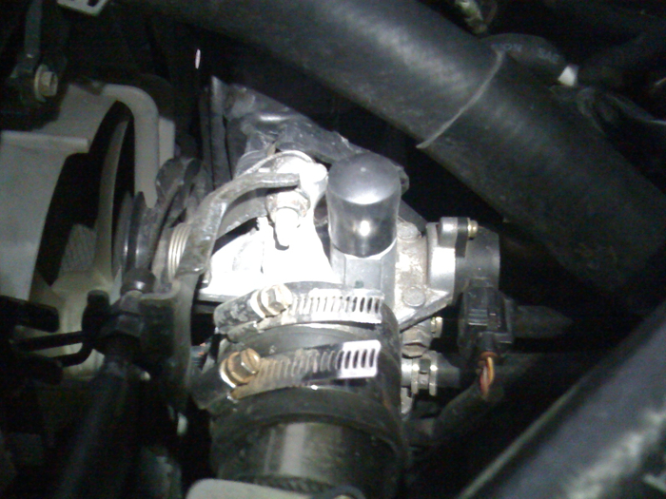
14. Connect your coolant lines. Remember they go on in the same order they came off of the stock throttle body.
15. Adapt your intake. You can get the stock intake over the new throttle body by prying it over with a flat head screw driver, by soaking the pipe in warm water, or getting a proper hose adapter. Making your intake work is up to you.
16. Start your car up. You should have an idle somewhere around 2,000 rpm. You need to let it sit and idle for 15+ minutes until the ECU can learn the new throttle body and re-adjust idle. After mine ran for about 20-30 minutes, it idled at 500-600rpm just like stock.
I noticed a significant improvement in torque throughout both low and top end. Also, the sluggishness on 4th gear on manual transmission xB's is significantly lowered.

